**ECE211-L LAB 7**

**Lab 7 Report: Design and Implementation of a Hamming Code-Based Error Correction System**

*Efe CIVISOKEN*

*Knycalus GREEN-JONES*

*04/03/2025*

*Statement of Collaboration:* Efe and Knycalus collaborated on all aspects of this lab. Both contributed to understanding the Hamming code principles and applying them to the design of the parity generator, error position indicator, and error corrector modules. Efe also contributed to deriving the logical equations to be used in the modules and wrote the whole top module. Testbenches were written and debugged jointly to ensure correctness of each component. The lab report was co-authored, with Kyncalus writing the *TESTING & RESULTS* and *DISCUSSION & CONCLUSION* sections while Efe wrote everything else on the report.

**Time Spent:** 7 hours.

**I. INTRODUCTION**

Reliable data transmission is a foundational requirement in digital systems. When binary data is transmitted over a channel or stored in memory, it is subject to external effects such as interference, degradation, or corruption. To minimize the negative outcomes of these, error detection and correction techniques are employed to ensure the integrity of the data. Among the simplest and most effective of these techniques is the Hamming Code, which provides a method of detecting and correcting single-bit errors.

The objective of this lab was to design and implement a complete Hamming (7,4) code system using SystemVerilog and deploy it onto the Nexys A7 FPGA board. The system encodes a 4-bit data word by generating three additional parity bits, forming a 7-bit codeword. Upon receiving a potentially corrupted 7-bit signal, the system identifies whether an error occurred, determines the exact bit position if an error is present, and corrects the corrupted bit.

This lab project was divided into several core components: a **parity generator (encoder)** that produces parity bits from a 4-bit input, an **error position indicator** that detects the error location based on inverted syndrome logic, and an **error corrector** that flips the erroneous bit. All modules were individually tested using simulation testbenches and were later integrated into a complete top-level design. The design was then synthesized, implemented, and tested on the FPGA board using switches and LEDs for input/output, as well as seven-segment displays for real-time data visualization.

**II. DESIGN**

**II.I The Theoretical Background of Hamming Code**

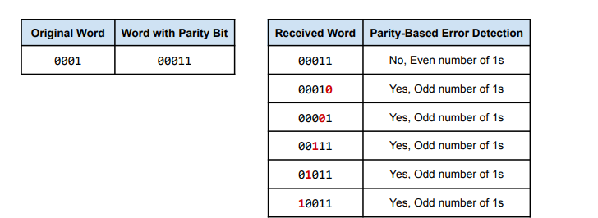

**Table 1**. Detecting Single-Bit Errors in the Message “0001” via a Parity Bit

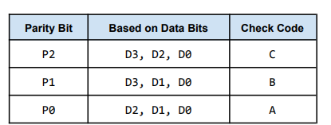

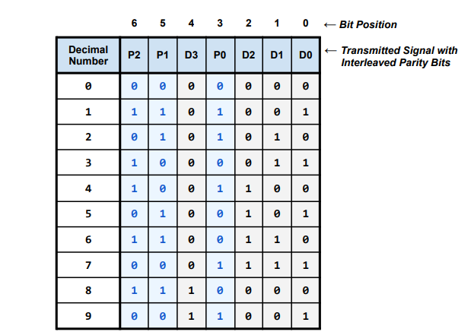**Table 2**. Parity Bits for Hamming Code

**Table 3.** Hamming Code Representation for Decimal Numbers 0-9

The Hamming (7,4) code takes a 4-bit data input (D3, D2, D1, D0) and encodes it into a 7-bit codeword by adding three parity bits (P2, P1, P0). These parity bits are strategically positioned and calculated to enable the identification and correction of any single-bit error. The final encoded message is ordered in the following bit positions: **[P2, P1, D3, P0, D2, D1, D0],** with position 6 being the MSB and position 0 the LSB.

Each parity bit is responsible for covering specific positions:

* P2 (position 6) checks bits at positions 6, 4, 2, 0 → {P2, D3, D2, D0}
* P1 (position 5) checks bits at positions 5, 4, 1, 0 → {P1, D3, D1, D0}
* P0 (position 3) checks bits at positions 3, 2, 1, 0 → {P0, D2, D1, D0}

These relationships, which are also demonstrated in Tables 1-3, ensure that any single-bit error results in a unique 3-bit syndrome, allowing precise localization of the error by specific calculations that are going to be explained in the further parts of the DESIGN section.

**II.II Parity Generator (Hamming Encoder) Module**

This module takes the 4-bit input data and calculates three parity bits using XOR gates to enforce even parity:

* **P2 = D3 ⊕ D2 ⊕ D0**
* **P1 = D3 ⊕ D1 ⊕ D0**
* **P0 = D2 ⊕ D1 ⊕ D0**

The output of this module is a 3-bit vector {P2, P1, P0}. These are then combined with the input data to form the 7-bit Hamming codeword.

module ParityGenerator(input logic [3:0] D,

output logic [2:0] P);

xor(P[0], D[0], D[1],D[2]);

xor(P[1], D[0], D[1],D[3]);

xor(P[2], D[0], D[2],D[3]);

endmodule

**Code 1. “parity_generator.sv” Module**

**Testbench 1.** Confirming the test cases and demonstrating the fully intended functionality of the module.

**II.III Error Position Indicator (Syndrome Generator) Module**

The received 7-bit codeword may contain a single-bit error. To detect the error and identify its position, the module recalculates the parity check results:

* **C = P2 ⊕ D3 ⊕ D2 ⊕ D0**
* **B = P1 ⊕ D3 ⊕ D1 ⊕ D0**
* **A = P0 ⊕ D2 ⊕ D1 ⊕ D0**

Furthermore, these values are inverted and then used to form a 3-bit check code {A’, B’, C’}, that points to the error position (in binary), where:

* 000 means bit 0 is in error,
* 001 means bit 1 is in error,
* ...
* 110 means bit 6 is in error,
* 111 is assumed to be correct in this design.

This method allows the system to detect and precisely locate any single-bit error within the 7-bit received signal, which can be further seen in the Code 2.

module error_position_indicator(input logic [6:0] IN,

output logic [2:0] CC);

logic WC;

logic WB;

logic WA;

xor (WC, IN[6], IN[4], IN[2], IN[0]);

not (CC[2], WC);

xor (WB, IN[5], IN[4], IN[1], IN[0]);

not (CC[1], WB);

xor (WA, IN[3], IN[2], IN[1], IN[0]);

not (CC[0], WA);

endmodule

**Code 2. “error_position_indicator.sv” Module.**

**Testbench 2**. Confirming the test cases and demonstrating the fully intended functionality of the module.

**II.IV Error Corrector Module**

The error corrector takes two inputs: the 3-bit check code (error location) and the original 4-bit data portion extracted from the received signal. Based on the error location, the module flips the erroneous bit. This is typically, just like implemented here, done with a case statement inside an always_comb block, where one bit of the 4-bit word is flipped based on the binary value of the check code. If the error position corresponds to a data bit (positions 0, 1, 2, or 4), that bit is inverted; otherwise, the original data is returned unchanged.

This correction allows recovery of the original data even if one bit has been flipped during transmission or storage.

module error_corrector(input logic [2:0] CC,

input logic [3:0] DR,

output logic [3:0] DC);

always_comb begin

DC = DR;

if (CC == 3'b000) begin

DC[0] = ~DR[0]; //Data bit 0

end

if (CC == 3'b100) begin

DC[1] = ~DR[1]; //Data bit 1

end

if (CC == 3'b010) begin

DC[2] = ~DR[2]; //Data bit 2

end

if (CC == 3'b001) begin

DC[3] = ~DR[3]; //Data bit 4

end

end

endmodule

**Code 3. “error_corrector.sv” Module.**

**Testbench 3.** Confirming the test cases and demonstrating the fully intended functionality of the module.

**III. IMPLEMENTATION**

The top-level module lab07_top integrates all components of the Hamming code system and maps them to the physical I/O of the Nexys A7 FPGA board. The 4-bit input data is taken from the upper switches SW[15:12], assigned to the vector D. This 4-bit data is passed into the ParityGenerator module, which calculates the three parity bits P[2:0] according to the Hamming encoding rules. These parity bits are then inserted into specific positions along with the data bits to form the 7-bit Hamming-encoded value TransmittedData. The bit order follows the required format: {P2, P1, D3, P0, D2, D1, D0}, with each bit explicitly assigned to its position using assign statements.

To simulate errors in transmission, the TransmittedData signal is passed into the provided error_injector module along with a 7-bit one-hot vector from switches SW[6:0], which selects the bit position to flip. The output of this module, named DamagedData, represents the potentially corrupted 7-bit signal.

The DamagedData signal is then analyzed by the error_position_indicator module, which produces a 3-bit output ErrorPosition, identifying the location of a single-bit error (if present). This check code corresponds to bits A, B, and C in the Hamming decoding process.

To isolate the data portion of the damaged signal, DamagedData is deconstructed into a 4-bit vector named RawDamagedData. The relevant data bits (D3, D2, D1, D0) are extracted from DamagedData based on their positions in the original Hamming format.

The RawDamagedData and ErrorPosition are passed into the error_corrector module, which outputs CorrectedData — the error-corrected 4-bit value. This corrected data is the final recovered version of the originally transmitted message.

For visual feedback and testing, the original and corrupted 7-bit codewords are displayed on the FPGA board’s LEDs. LED[15:9] shows the original encoded signal before error injection, and LED[6:0] displays the corrupted signal after injection. The seven-segment display is driven by the hamming_display module, which receives the original data D, the corrected data CorrectedData, and the check bits A, B, and C (mapped from ErrorPosition[0], ErrorPosition[1], and ErrorPosition[2] respectively). This display provides a clear visual comparison of the input and the corrected output, verifying that the system successfully detects and corrects single-bit errors.

The entire system was synthesized in Vivado, implemented on the FPGA, and tested by toggling the switches to enter various data values and inject errors. The outputs on the LEDs and seven-segment display consistently reflected correct error detection and correction, demonstrating successful implementation of the Hamming code encoder-decoder pipeline.

module lab07_top(

input logic clk,

input logic [15:0] SW,

output logic [15:0] LED,

output logic [6:0] SEG,

output logic [7:0] AN

);

logic [3:0] D;

logic [2:0] P;

logic [6:0] TransmittedData;

assign D = SW[15:12];

ParityGenerator pg(.D(D), .P(P));

assign TransmittedData[6] = P[2];

assign TransmittedData[5] = P[1];

assign TransmittedData[4] = D[3];

assign TransmittedData[3] = P[0];

assign TransmittedData[2] = D[2];

assign TransmittedData[1] = D[1];

assign TransmittedData[0] = D[0];

logic [6:0] DamagedData;

error_injector ei(.In(TransmittedData), .Pos(SW[6:0]), .Out(DamagedData));

logic [2:0] ErrorPosition;

error_position_indicator(.IN(DamagedData), .CC(ErrorPosition));

logic [3:0] RawDamagedData;

assign RawDamagedData[3] = DamagedData[4];

assign RawDamagedData[2] = DamagedData[2];

assign RawDamagedData[1] = DamagedData[1];

assign RawDamagedData[0] = DamagedData[0];

logic [3:0] CorrectedData;

error_corrector(.DR(RawDamagedData), .CC(ErrorPosition), .DC(CorrectedData));

assign LED[15:9] = TransmittedData;

assign LED[6:0] = DamagedData;

// Use this code to connect to the seven-segement display during Part 5 of the lab

hamming_display DISP(

.d_tr(D), /* Connect original, transmitted D3-D0 */

.d_rc(CorrectedData), /* Connect received, corrected D3-D0 */

.a(ErrorPosition[0] ), /* Connect correct code bit A */

.b(ErrorPosition[1] ), /* Connect correct code bit B */

.c( ErrorPosition[2]), /* Connect correct code bit C */

.clk(clk), .seg_n(SEG), .an(AN)

);

endmodule

**Code 4. “lab07_top.sv” Module.**

**IV. TESTING AND RESULTS**

Tests went as expected. For starters, switches 15 to 12 were each used to select binary numbers. If a switch was in the off/downward position, that meant that the digit that lines up with that switch would be 0. If a switch was in the on/upward position, that meant that the digit that lines up with that switch would be 1. Whatever the configuration of the numbers ends up being, pertaining to each switch position, is the 4-bit binary representation on the seven segment display. In correspondence on the left hand side of the display, there are lights that are on the right which turn on/off depending on what digits are being used on the left side. If one of those switches associated with those lights are toggled, the system produces an error with an “apostrophe” symbol. Figures below are shown for interpretation.

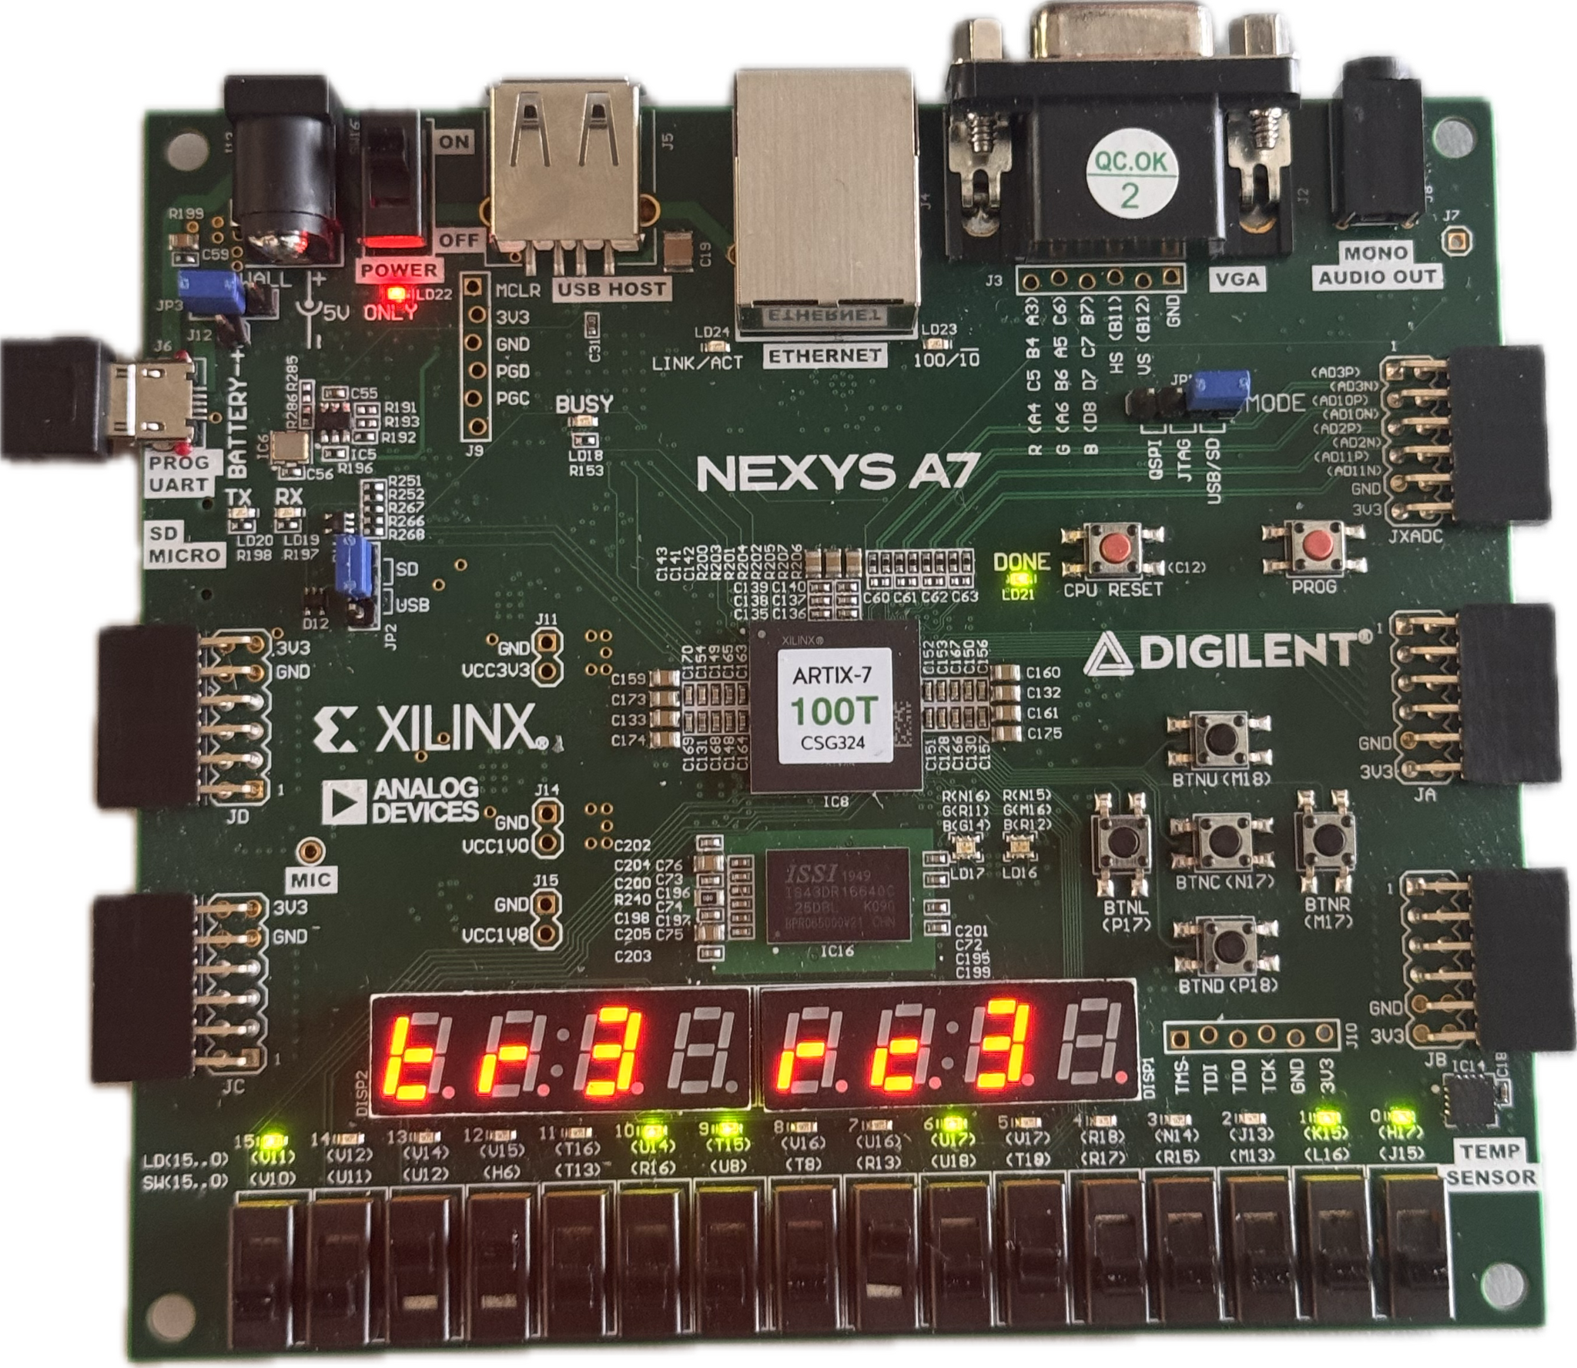

Figure 1: Binary 3 represented through switches 12 & 13 in the upward positions to make 0011

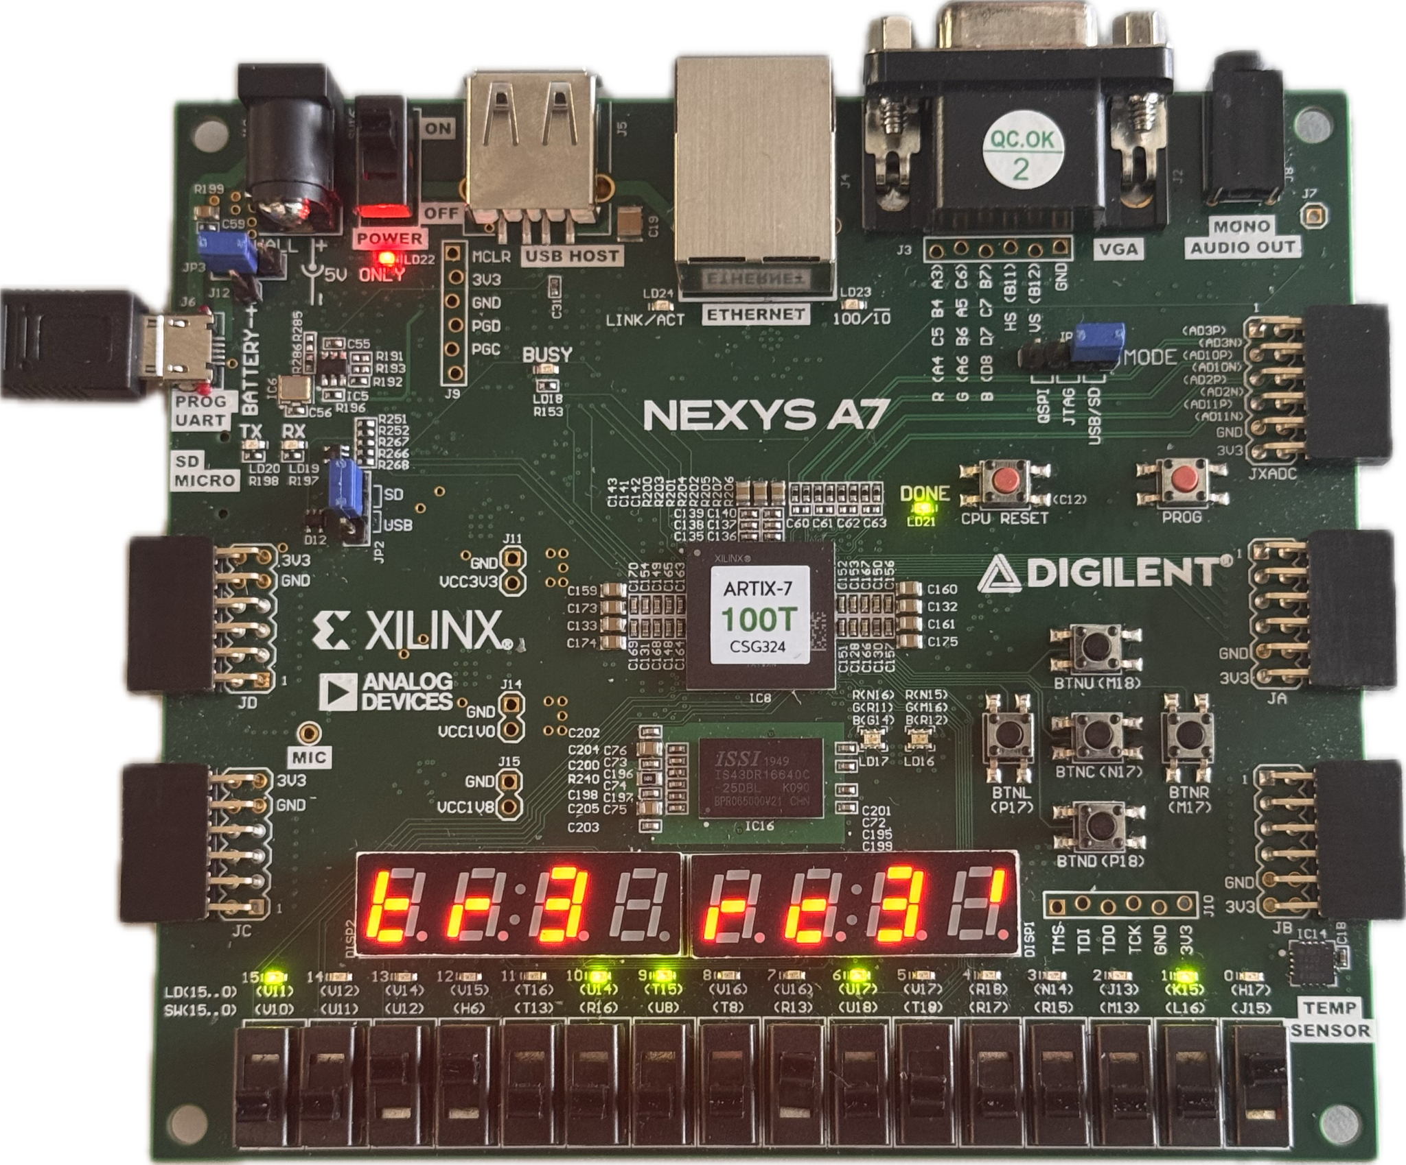

Figure 2: Binary 3 represented through switches 12 & 13 in the upward positions to make 0011

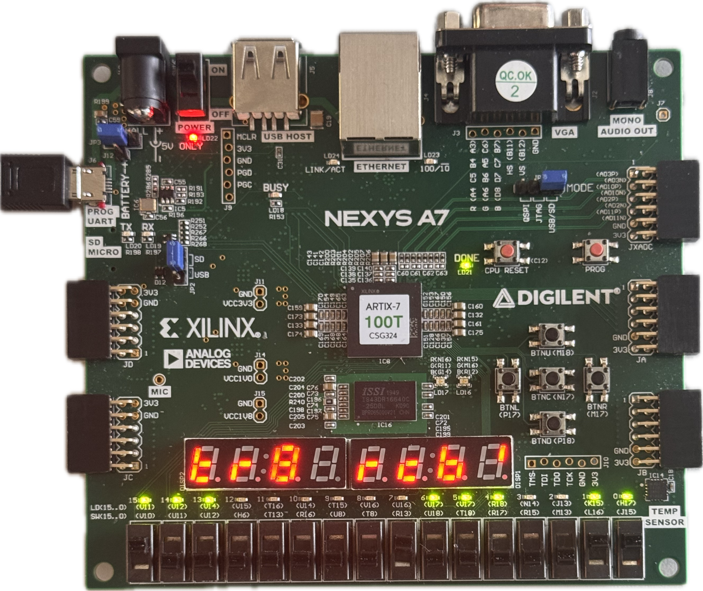

Figure 3: Received signal changes when there is more than one error

**V. DISCUSSION AND CONCLUSION**

All in all, Lab 7 was a success. Going over things one more time, Hamming Code implementation was done to make an error detecting module that instantiates not only in the code, but on the seven segment display. Parity checks were utilized to add redundancy to data in order to catch single digit issues within a given binary value. A 16 row long table was made to test all of the different possibilities for each digit in a given 4 bit binary number. That table was then used to make case statements for the error detector and injector. This was then applied to the Nexys A7-100Ts switches, LEDs, and seven segment display.

**REFERENCES AND APPENDIX:**

* Lab Manual on Moodle Page of the Class.